EXERCISE 17
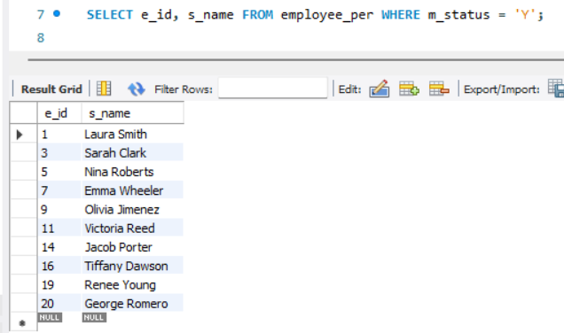
- Find and list the ids and spouse names of all employees who are married.

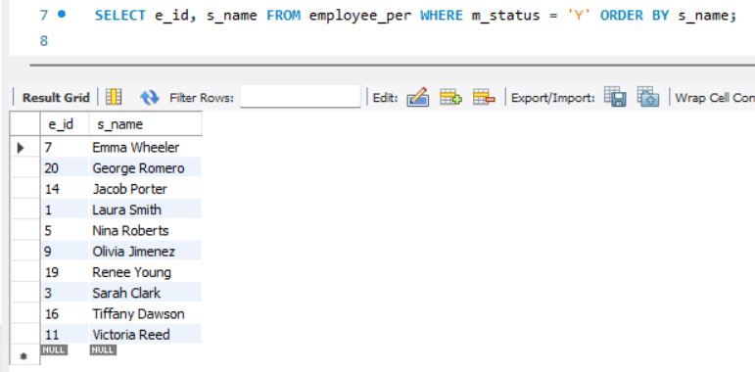
- Change the above so that the display is sorted on spouse names.

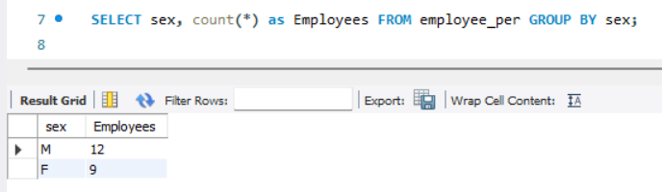
- How many employees do we have under each sex (male and female)?

- How many of our employees are married and unmarried?
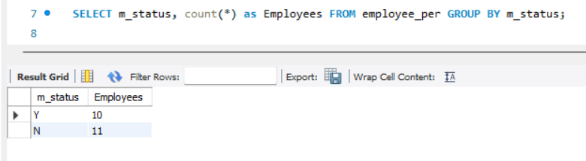

- Find to the total number of children.
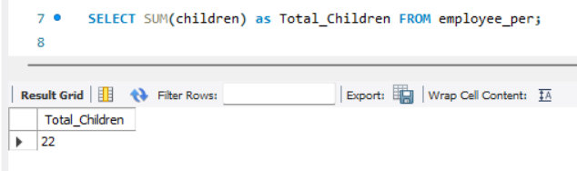

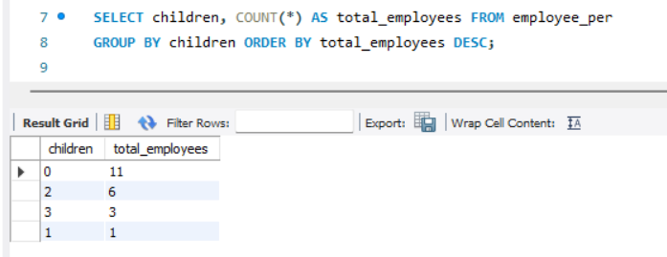
- Make unique groups of children and find the number in each group. Sort the display with the group having maximum children, at the top.

